Chapter 7, Problem 61.

In the circuit in Fig. 7.126, i_{s} changes from 5 A to 10 A at t = 0; that is, i_{s} = [5u(-t) + 10u(t)] A. Find v and i.

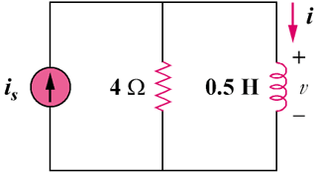

Figure 7.126
For Prob. 7.61.

